- Group member 1
Synthesize a strand of DNA that has the following sequence:
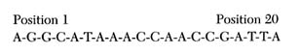
Label this strand "human DNA." This strand represents a small section of the gene that codes for human hemoglobin protein.

- Group member 2
Synthesize a strand of DNA that has the following sequence:
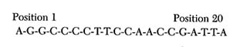
Label this strand "chimpanzee DNA." This strand represents a small section of the gene that codes for chimpanzee hemoglobin protein.
- Group member 3
Synthesize a strand of DNA that has the following sequence:
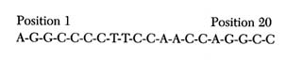
Label this strand "gorilla DNA." This strand represents a small section of the gene that codes for gorilla hemoglobin protein.
- Group member 4
Synthesize a strand of DNA that has the following sequence:
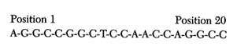
Label this strand "common ancestor DNA." This DNA strand represents a small section of the gene that codes for the hemoglobin protein of a common ancestor of the gorilla, chimpanzee, and human.

